________________
________________________________________________________________


Decision Modelling Case Studies

Module Code: BBM116 | Module Title: Decision Models
Submitted To: Ozren Despic

Student Name: | Jubair Islam Shourov
Student ID: | 260297046
Programme: | MSc Business Analytics
Date of Submission: | 26th May 2026

________________________________________________________________________________
________________
Word Count: 2447

Contents
CASE STUDY – 01 2
Answer to the Question No: 1 2
Answer to the Question NO: 02 4
Answer to the Question NO: 03 5
Case Study- 03 6
Answer to the Question NO: 01 6
Answer to the Question No: 02 7
Answer to the Question No: 03 8
Answer to the Question No: 04 8

CASE STUDY – 01

Answer to the Question No: 1
Let X_{ij} be the amount of paint (in tons) transported from source _{(i)} to destination _{(j).}
- X_{DR,} X_{DS,} X_{DE} : No. of Tons of paint transported from Durham to Reading, Sheffield, Edinburgh.
- X_{NR,} X_{NS}, X_{NE} : No. of Tons of paint transported from Norwich to Reading, Sheffield, Edinburgh
- X_{D1,} X_{D2,} X_{D3,} X_{D4}: No. of Tons of paint transported from Durham to directly Wholesalers 1, 2, 3, and 4
- X_{N1,} X_{N2,} X_{N3,} X_{N4} : No. of Tons of paint transported from Norwich to to directly Wholesalers 1, 2, 3, and 4
- X_{R1}, X_{R2}, X_{R3}, X_{R4}: Tons of paint from Reading to Wholesalers 1, 2, 3, and 4.
- X_{S1}, X_{S2}, X_{S3}, X_{S4}: Tons of paint from Sheffield to Wholesalers 1, 2, 3, and 4.
- X_{E1}, X_{E2}, X_{E3}, X_{E4}: Tons of paint from Edinburgh to Wholesalers 1, 2, 3, and 4.

Objective Function
Minimum Transportation Cost (MIN) = 57 X_{DS} + 48X_{DE} + 121X_{D1} + 101X_{D2} + 137X_{D4} + 54 X_{NR} + 58 X_{NS} + 98 X_{N2} + 105 X_{N3} + 150 X_{N4} + 59 X_{R1} + 41 X_{R3} + 67 X_{R4} + 52 X_{S1} + 62 X_{S2} + 67 X_{S3} + 72 X_{S4} + 72 X_{E1} + 67 X_{E2} + 48 X_{E3} + 59 X_{E4}

Constraints

Production cannot exceed the weekly limits of 83,000 tons for Durham
X_{DS} + X_{DE} + X_{D1} + X_{D2} + X_{D4} <= 83000
Production cannot exceed the weekly limits of 67,000 tons for Norwich
X_{NR} + X_{NS} + X_{N2} + X_{N3} + X_{N4} <= 67000
40,000 tons can be moved each week through the warehouse in Reading per week.
X_{NR} <= 40000
38,000 tons can be moved each week through the warehouse in Sheffield per week.
X_{DS} + X_{NS} <= 38000
36,000 tons can be moved each week through the warehouse in Edinburgh per week.
X_{DE} <= 36000
The total tons entering a warehouse of Reading from Factory Norwich must exactly equal the total tons leaving it to wholesaler 1,3 and 4
X_{NR} - X_{R1} - X_{R3} - X_{R4} = 0
The total tons entering a warehouse of Sheffield from Factory Durham and Norwich must exactly equal the total tons leaving it to wholesaler 1,2,3 and 4
X_{DS} + X_{NS} - X_{S1} - X_{S2} - X_{S3} - X_{S4} = 0
The total tons entering a warehouse of Edinburgh from Factory Durham must exactly equal the total tons leaving it to wholesaler 1,2,3 and 4
X_{DE} - X_{E1} - X_{E2} - X_{E3} - X_{E4} = 0
Wholesaler 1 weekly requirements is 48,000 tons
X_{D1} + X_{R1} + X_{S1} + X_{E1} <= 48000
Wholesaler 2 weekly requirements is 38,000 tons
X_{D2} + X_{N2} + X_{S2} + X_{E2} <= 38000
Wholesaler 3 weekly requirements is 21,000 tons
X_{N3} + X_{R3} + X_{S3} + X_{E3} <= 21000
Wholesaler 4 weekly requirements is 36,000 tons
X_{D4} + X_{N4} + X_{R4} + X_{S4} + X_{E4} <= 36000

Lindo Model

MIN 57 XDS + 48 XDE + 121 XD1 + 101 XD2 + 137 XD4 + 54 XNR + 58 XNS + 98 XN2 + 105 XN3 + 150 XN4 + 59 XR1 + 41 XR3 + 67 XR4 + 52 XS1 + 62 XS2 + 67 XS3 + 72 XS4 + 72 XE1 + 67 XE2 + 48 XE3 + 59 XE4
SUBJECT TO
! Factory Capacities
XDS + XDE + XD1 + XD2 + XD4 <= 83000
XNR + XNS + XN2 + XN3 + XN4 <= 67000
! Warehouse Capacities
XNR <= 40000
XDS + XNS <= 38000
XDE <= 36000
! Flow Balance (In - Out = 0)
XNR - XR1 - XR3 - XR4 = 0
XDS + XNS - XS1 - XS2 - XS3 - XS4 = 0
XDE - XE1 - XE2 - XE3 - XE4 = 0
! Wholesaler Demands
XD1 + XR1 + XS1 + XE1 = 48000
XD2 + XN2 + XS2 + XE2 = 38000
XN3 + XR3 + XS3 + XE3 = 21000
XD4 + XN4 + XR4 + XS4 + XE4 = 36000
END

Minimum Transportation cost: £14,849,000 per week
- X_{DS}: 38000 Tons of paint transported from Durham to Sheffield.
- X_{DE}: 36000 Tons of paint transported from Durham to Edinburgh.
- X_{D2,}: 2000 Tons of paint transported from Durham to directly Wholesalers 2.
- X_{NR}: 31000 Tons of paint transported from Norwich to Reading.
- X_{N2}: 36000 Tons of paint transported from Norwich to directly Wholesalers 2.
- X_{R1}: 10000 Tons of paint from Reading to Wholesalers 1
- X_{R3}: 21000 Tons of paint from Reading to Wholesalers 3
- X_{S1}: 38000 Tons of paint from Sheffield to Wholesalers 1
- X_{E4}: 36000 Tons of paint from Edinburgh to Wholesalers 4.

Answer to the Question NO: 02

From the Lindo Sensitivity analysis we can tells what happens to total cost (£14,849,000) if we change the size of factories or warehouses.
The Dual Price tells us exactly how much our total cost will change if we add or remove 1 ton of capacity
- Durham & Reading: These have a Dual Price of 0. This is because they have Slack extra space they aren't even using yet. Adding or taking away 1 ton does nothing to the cost.
- Norwich & Sheffield: These are "Binding," meaning they are 100% full.
  - Norwich : Adding 1 ton of capacity would increase your costs by 3.
  - Sheffield : Adding 1 ton of capacity would increase your costs by 7.
Regarding Sheffield, we see its current limit is 38,000 tons.
- To change the routes by adding, we must add more than 2,000 tons.
- To change the routes by substracting, we must take away more than 9,000 tons.
Right now, this plan is perfectly balanced. If we stay within the +2,000 or -9,000 range, keep using the same roads and warehouses; we just change the amount of paint on the trucks.
However, if you go outside these numbers:
- If we add more than 2,000 tons to Sheffield: The old way of shipping isn't the best anymore. The model will find a brand new path that was previously too expensive but now makes sense because Sheffield has so much room.
- If you reduce more than 9,000 tons from Sheffield: We have made Sheffield so small that the current shipping plan becomes impossible. The model will be forced to use a different warehouse (like Edinburgh) or ship directly from a factory to a wholesaler, even if it costs more.

Answer to the Question NO: 03

Decision Variables are similar like question No: 01. Still here are the decision variables
- X_{DS}, X_{DE}, X_{D1}, X_{D2}, X_{D4}: Tons of paint moved from the Durham factory to Sheffield, Edinburgh, and Wholesalers 1, 2, and 4.
- X_{NR}, X_{NS}, X_{N2}, X_{N3}, X_{N4}: Tons of paint moved from the Norwich factory to Reading, Sheffield, and Wholesalers 2, 3, and 4.
- X_{R1}, X_{R3}, X_{R4}: Tons from the Reading warehouse to Wholesalers 1, 3, and 4.
- X_{S1}, X_{S2}, X_{S3}, X_{S4}: Tons from the Sheffield warehouse to Wholesalers 1, 2, 3, and 4.
- X_{E1}, X_{E2}, X_{E3}, X_{E4}: Tons from the Edinburgh warehouse to Wholesalers 1, 2, 3, and 4.
Binary & Integer Variables:
- Y_{R}, Y_{S}, Y_{E}: Binary variables (0-1). Y=1 if the respective warehouse stays open; Y=0 if it is closed down.
- L_{E}: General integer variable representing the number of 1,000-ton units sub-let at the Edinburgh warehouse.
Lindo Model

MIN 57 XDS + 48 XDE + 121 XD1 + 101 XD2 + 137 XD4 + 54 XNR + 58 XNS + 98 XN2 + 105 XN3 + 150 XN4 + 59 XR1 + 41 XR3 + 67 XR4 + 52 XS1 + 62 XS2 + 67 XS3 + 72 XS4 + 72 XE1 + 67 XE2 + 48 XE3 + 59 XE4 - 28000 LE

SUBJECT TO
! Factory Supply Limits
XDS + XDE + XD1 + XD2 + XD4 <= 83000
XNR + XNS + XN2 + XN3 + XN4 <= 67000

! Wholesaler Demand Requirements
XD1 + XR1 + XS1 + XE1 = 48000
XD2 + XN2 + XS2 + XE2 = 38000
XN3 + XR3 + XS3 + XE3 = 21000
XD4 + XN4 + XR4 + XS4 + XE4 = 36000

! Warehouse Flow Balance (Tons In = Tons Out)
XNR - XR1 - XR3 - XR4 = 0
XDS + XNS - XS1 - XS2 - XS3 - XS4 = 0
XDE - XE1 - XE2 - XE3 - XE4 = 0

! Warehouse Capacity & Sub-letting Limits
XR1 + XR3 + XR4 - 40000 YR <= 0
XS1 + XS2 + XS3 + XS4 - 38000 YS <= 0
XE1 + XE2 + XE3 + XE4 + 1000 LE - 36000 YE <= 0

! Warehouse Closure Mandate (Exactly one must close)
YR + YS + YE = 2

END
INT YR
INT YS
INT YE
GIN LE
This model calculates the absolute lowest total logistics cost while fulfilling all demands. The objective function minimizes the transport costs, but crucially, it subtracts £28,000 for every block (L_{E}) of capacity sub-let at Edinburgh. The constraints ensure that no factory exceeds its maximum output. Warehouses only ship what they receive, capacities are not breached, and exactly one warehouse is completely shut down (Y_{R} + Y_{S} + Y_{E} = 2). Furthermore, if Edinburgh is closed (Y_{E} = 0), the capacity constraint forces L_{E} to be 0, ensuring you cannot sub-let a closed facility.
Recommendation
Maximize Edinburgh Sub-lets: According to me, the company sub-lets as much capacity at Edinburgh as physically possible without violating demand constraints. Because the sub-let value is estimated at £28,000 per 1,000 tons (£28/ton), this revenue easily offsets the slight increase in transportation costs incurred by routing paint through other locations.
Closing a warehouse restricts flow and forces the model to use less efficient, more expensive routes. However, the model evaluates whether the £28/ton sub-letting profit at Edinburgh is worth the disruption. Structuring the model this way provides mathematically guaranteed optimal logistics.
For any specific advice on whether to actually execute the closure, we must ask management for the specific, projected labour and maintenance savings for each warehouse. Right now, the model minimizes the transportation costs. If the logistics penalty of closing the reading warehouse is £50,000, but the labour savings are £100,000, it's a good decision. We need those fixed cost figures to compare.

CASE STUDY- 03

Answer to the Question NO: 01

Option-01: Sell the Design= If the company sells the design immediately, the guaranteed EMV is €500,000.
Option-02: Launch with No Testing
- Expected Gross Profit = (0.10 * €2,000,000) + (0.20 * €1,000,000) + (0.40 * €500,000) + (0.30 * €100,000) = €630,000.
- Node EMV (Expected Monetary Value) = Expected Gross (€630,000) - Launch Cost (€300,000) = €330,000.
Option-03 Conduct Testing
If we work backward from the final test to the first.
- Sub-decision: Launch after passing both tests
    - Expected Gross = (0.20 * €2,000,000) + (0.45 * €1,000,000) + (0.30 * €500,000) + (0.05 * €100,000) = €1,005,000.
    - EMV of Launch = €1,005,000 - €300,000 = €705,000.
- Sub-decision: Market Test Node
- Expected Value = (0.9 * €705,000) + (0.1 * €0) = €634,500.
- Node EMV = €634,500 - €100,000 = €534,500.
Main Decision: Product Test Node
  - Expected Value = (0.8 * €534,500) + (0.2 * €0) = €427,600.
  - Node EMV = €427,600 - €100,000 = €327,600.
Comparing all of theoptions
1. Sell Product Design: €500,000, 2. Launch (No Testing): €330,000 3. Conduct Product Testing: €327,600
The company should sell the product design for €500,000. It provides the highest expected value and completely eliminates the financial risk associated with testing and launching.

Answer to the Question NO: 02
We must recalculate the EMVs assuming the profit from a highly successful product is now estimated to be €3,500,000 rather than €2,000,000.
- Option 1: Sell Design= €500,000.
- Option 2: Launch (No Testing)
  - Expected Gross = (0.10 * €3,500,000) + (0.20 * €1,000,000) + (0.40 * €500,000) + (0.30 * €100,000) = €780,000.
  - Node EMV = €780,000 - €300,000 = €480,000.
- Option 3: Conduct Testing
  - Launch after passing both tests: Expected Gross = (0.20 * €3,500,000) + (0.45 * €1,000,000) + (0.30 * €500,000) + (0.05 * €100,000) = €1,305,000.
  - EMV of Launch = €1,305,000 - €300,000 = €1,005,000.
  - Market Test Node: (0.9 * €1,005,000) + (0.1 * €0) - €100,000 = €804,500.
  - Product Test Node: (0.8 * €804,500) + (0.2 * €0) - €100,000 = €543,600.
With the increased potential payoff, the highest EMV is now €543,600. The company should initiate Product Testing. If it passes, they should proceed to Market Testing. If that passes, they should launch.

Answer to the Question NO: 03
If the company follows the recommendation to Product Test, then Market Test, and finally Launch (if both tests are passed), there are six possible "real-world" outcomes. The table below summarizes the financial results, taking into account the accumulated costs at each stage:
- Product Test Cost: €100,000.
- Market Test Cost: €100,000.
- Launch Cost: €300,000.
- Total Investment to Reach Launch: €500,000
Outcome Scenario | Probability Calculation | Final Probability | Net Financial Value (Profit minus all incurred costs)
Product Test Fails | 0.20 | 20.0% | -€100,000 (Cost of product test)
Product Test Passes, Market Test Fails | 0.80 * 0.10 | 8.0% | -€200,000 (Cost of both tests)
Both Pass, Launch -> Highly Successful | 0.80 * 0.90 * 0.20 | 14.4% | €3,000,000 (€3.5M gross - €500k costs)
Both Pass, Launch -> Moderately Successful | 0.80 * 0.90 * 0.45 | 32.4% | €500,000 (€1M gross - €500k costs)
Both Pass, Launch -> Low Success | 0.80 * 0.90 * 0.30 | 21.6% | €0 (€500k gross - €500k costs; break-even)
Both Pass, Launch -> Failure | 0.80 * 0.90 * 0.05 | 3.6% | -€400,000 (€100k gross - €500k costs)

Answer to the Question No: 04
If I were a human decision-maker running this company, I would likely disregard the decision tree model's recommendation for Part 2 and choose to sell the design for €500,000.
While decision trees optimize for EMV, assumes the decision-maker is entirely risk-neutral and will play this scenario thousands of times to realize the average. In reality, a company only plays this scenario once.
Looking at the table in Part 3 reveals the severe practical risks:
- There is a 31.6% chance of losing money (losing €100k, €200k, or €400k).
- There is an additional 21.6% chance of making zero profit after doing all the work.
- Combined, there is a 53.2% chance that taking the risk yields a result worse than or equal to €0.
- There is only a 46.8% chance of actually making a profit.

The tree suggests choosing testing because it has an EMV of €543,600 compared to the guaranteed €500,000 from selling the design. However, taking on a 53.2% chance of absolute failure or stagnation just to chase a purely mathematical premium of €43,600 in expected value is a poor choice for any risk-averse or moderately conservative business.

Appendices
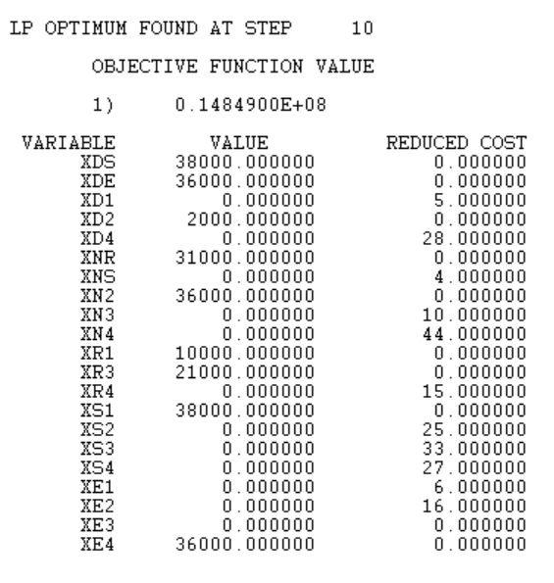
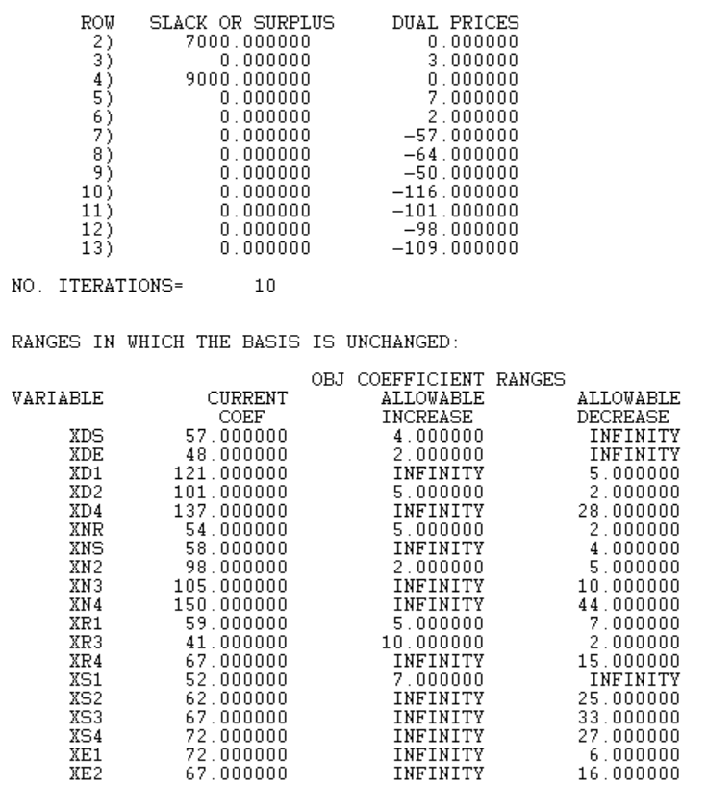

Lindo Model Solution Picture
Case Study No: 01
Answer to the Question No; 01

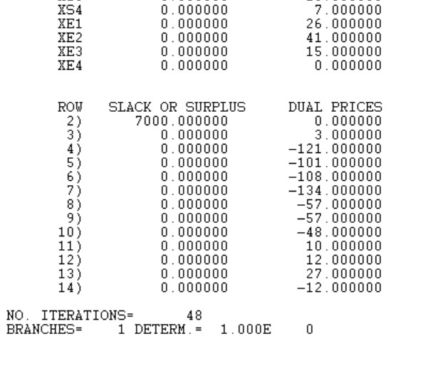
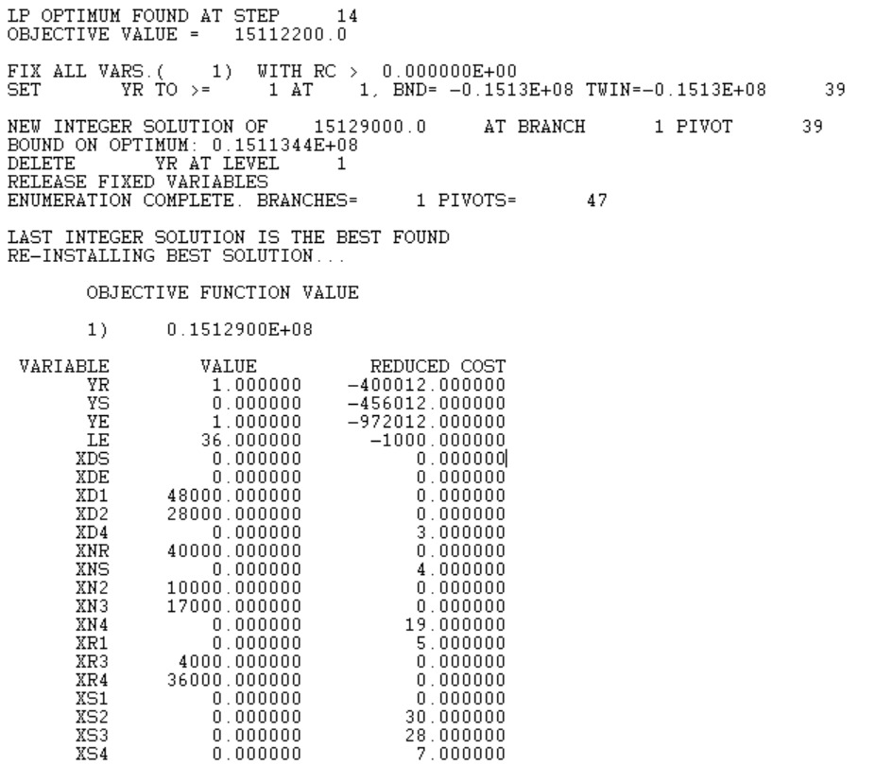
Lindo Model Solution Picture
Case Study No: 01
Answer to the Question No; 03
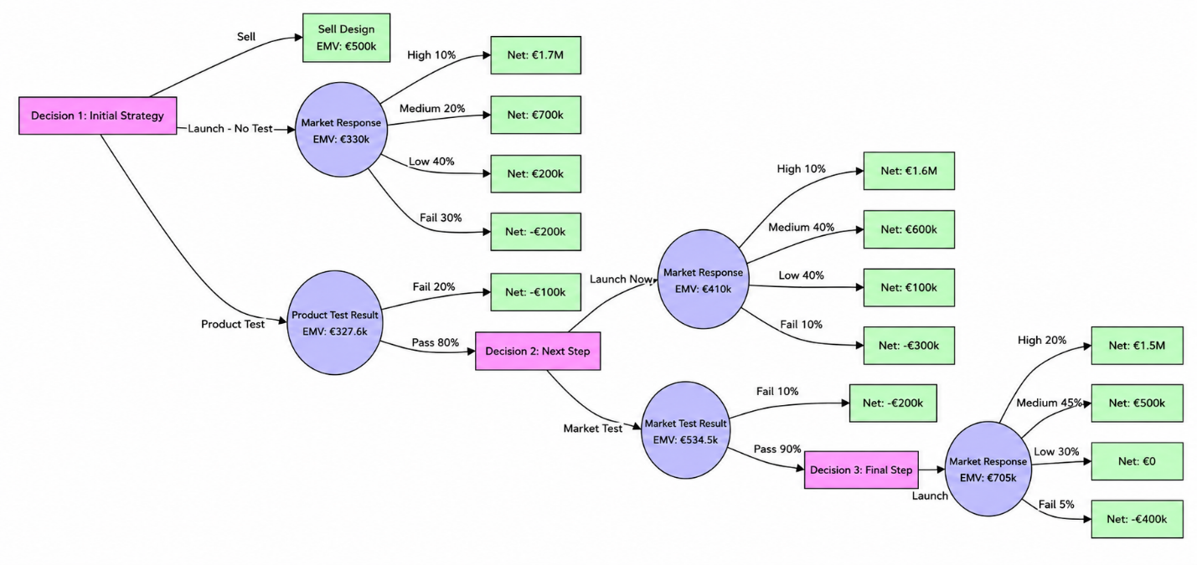
Decision Tree
Case Study No: 03
Answer to the Question No; 02

